**Kingdom of Saudi Arabia**

**Ministry of Education**

**University of Hail**

**College of Computer Science & Engineering**

**Department of Computer Science & Information**

­­­

**Assignment**

|  |
| --- |
| **SWE-344: Internet Protocols and C/S Programming** |
| **Second Semester 2019/2020**   |  |  | | --- | --- | | **Submission Date: 25/3/2020** | **Marks:** | | **Student Name: yosef mohammed** | **Student ID :201616761__** | |

**Assignment title**: Exercise 1: Simple Calculator

**

**Assignment title: Exercise 2: Adding/Removing Elements to/from ListBox and attaching ListBox to Button:**

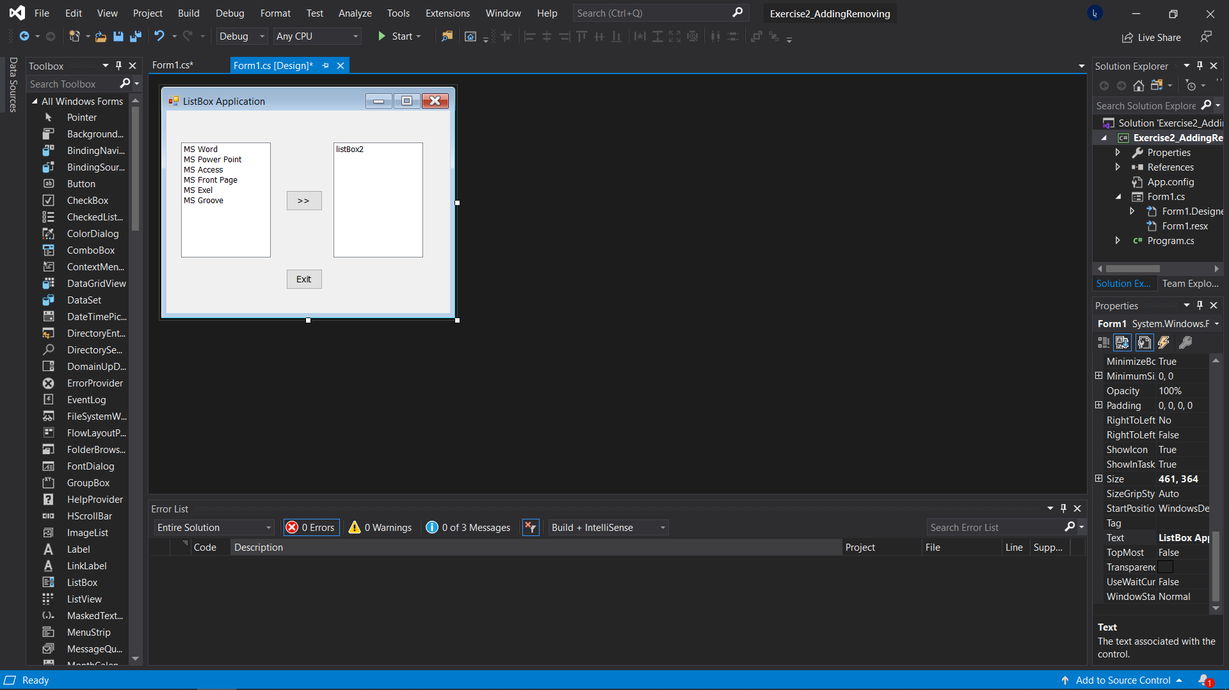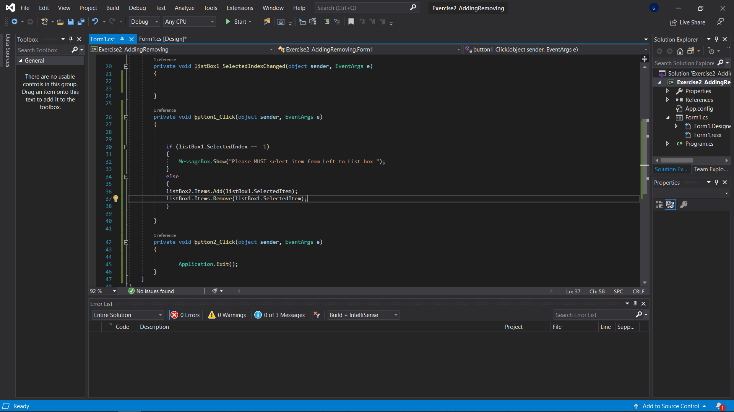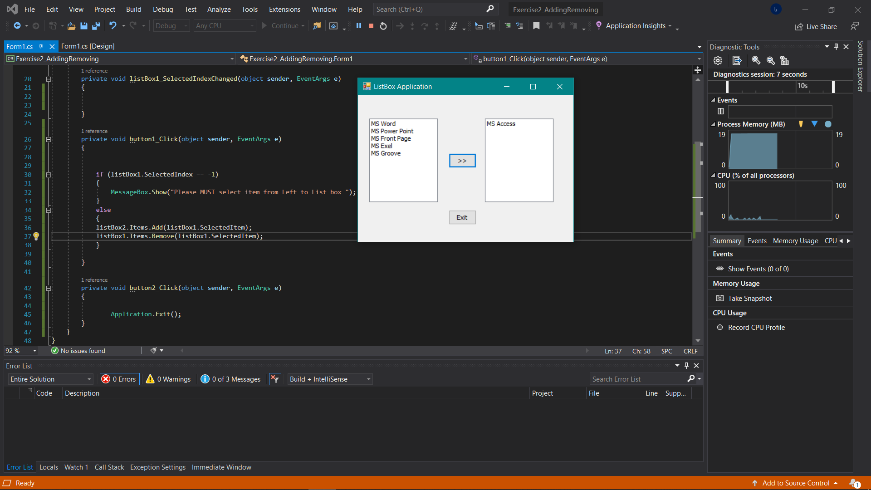

**Exercise 3: Adding/Removing Elements to/from treeView**

**

**Exercise 4: Age Calculator by using dateTimePicker control:**

**Exercise 5: Adding/Removing Elements to/from listView with help of contextMenu controls**

